* Wenn du sagen willst, was jemand tun sollte, dann verwendest du should.
* Wenn du sagen willst, was jemand nicht tun sollte, dann verwendest du shouldn´t.
* Wenn du um Rat fragst, dann verwendest du ebenfalls should.

**Bildung**: should/shouldn´t + base form (Nennform) des Zeitwortes.

**1. Complete each sentence with using should or shouldn´t and the correct box!**

look for a different job

go to the doctor

buy a new one

eat burgers anymore

go to a restaurant

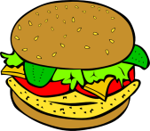

take an umbrella

have a party

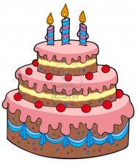

You look terrible. I think you _________________________________________.

‘I really hate this job.’ ‘Well, then you _________________________________.’

It´s raining. So you __________________________________________________.

It´s Jane´s birthday on Saturday, so I think we __________________________.

Food from Burger King is very unhealthy. You __________________________.

‘I´m really hungry now.’ ‘Ok, so we __________________________________.’

The car didn´t start again this morning. Do you think we _________________.

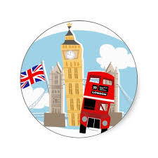**2. Match sentences 1–5 with sentences A–E.**

1. What should I visit when I go to London? A. We don’t want to get lost.
2. You shouldn’t go off on your own. B. You should visit The London Eye.
3. We should take a map with us. C. In front of the monument.
4. You shouldn’t forget to take an umbrella. D. We should stay together.
5. Where should we meet you? E. It often rains in London.

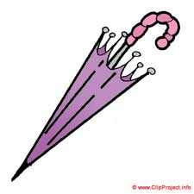**3. Read the sentences and fill in should or shouldn´t!**

1) If it´s rainy you  take an umbrella.

2) Tom  eat so many lollipops. It´s bad for his teeth.

3) a)  I drink hot tea if I have a sore throat?

b) Yes, you .

4) They have a test tomorrow. They  go to the cinema. They  stay at home and study!

5) Children  eat lots of vegetables, but they  eat lots of sweets.

6) I have a party tonight. What I wear? A dress or a pair of trousers?

7) The doctor said: "You  eat healthy food. You  eat fast food.