Asking the way - Vocabulary
Useful phrases

Picture | English sentence
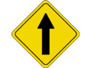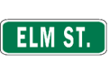 | Go straight on Elm Street.
 | Go along Elm Street.
 | Go down Elm Street.
 | Follow Elm Street for 200 metres.
 | Follow Elm Street until you get to the church.
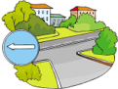 | Turn left into Oxford Street.
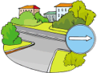 | Turn right into Oxford Street.
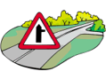 | Take the first turning on the right.
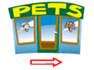 | Go past the pet shop.
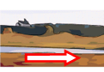 | Go along the river.
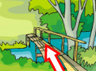 | Go over the bridge.
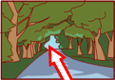 | Go through the park.
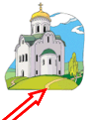 | Go towards the church.
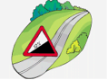 | Go up the hill.
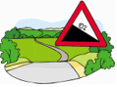 | Go down the hill.
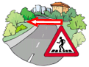 | Cross Oxford Street.
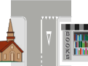 | The bookshop is opposite the church.
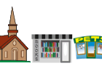 | The bookshop is between the church and the pet shop.
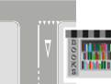 | The bookshop is on/at the corner.
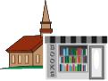 | The bookshop is in front of the church.
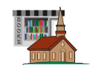 | The bookshop is behind the church.
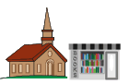 | The bookshop is next to the church.
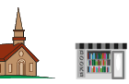 | The bookshop is beside the church.
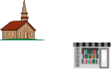 | The bookshop is near the church.
Useful words:
>
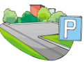 | car park  parking lot (AE)
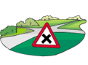 | crossroads
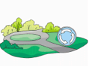 | roundabout
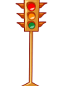 | traffic lights

