can or can´t
Form sentences: What can you do? What can´t you do?
 | I can ice dance.
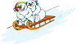

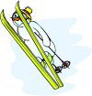


My name is ……………

