like or don´t?
Form sentences: What do you like? What don´t you like?
I like to play football.
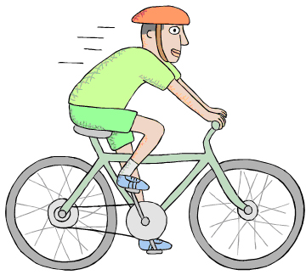


My name is …………………………

