FRIENDS My best friend

I) Study the words:

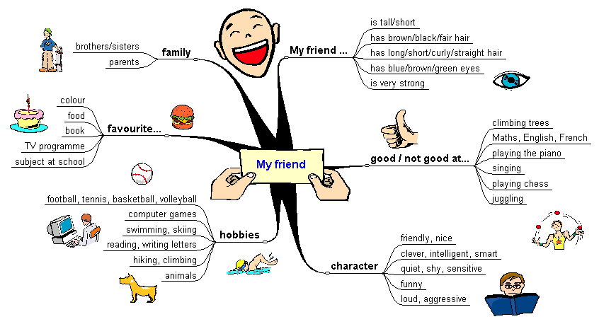

II) Interview a friend and take notes:
Name | family | What he/she looks like | character | hobbies | good at | favourite things

III) Write a text about a friend:
Complete the sentences.
Use a different colour for the words you add.
Write your text on a new page (Manueller Seitenwechsel).

My best friend’s name is .…
He/she is….years old.
I think he/she looks great: …..
…..
…..
… is very good at ….., but….
I think he/she is ….
His/her favourite … is …..
He/she often ….
He/she never ….
I sometimes help …. with …..
We both like ….
….
….
Last week we ….
Next weekend we …..

Additional tasks:

- Füge ein passendes Bild und einen Rahmen/Seitenrand ein.
- Zentriere den Text und ändere Schriftart und Schriftgröße.

Interview some more friends and take notes:
Name | family | What he/she looks like | character | hobbies | good at | favourite things

