HOLIDAYS Interview

- Study the following words and phrases

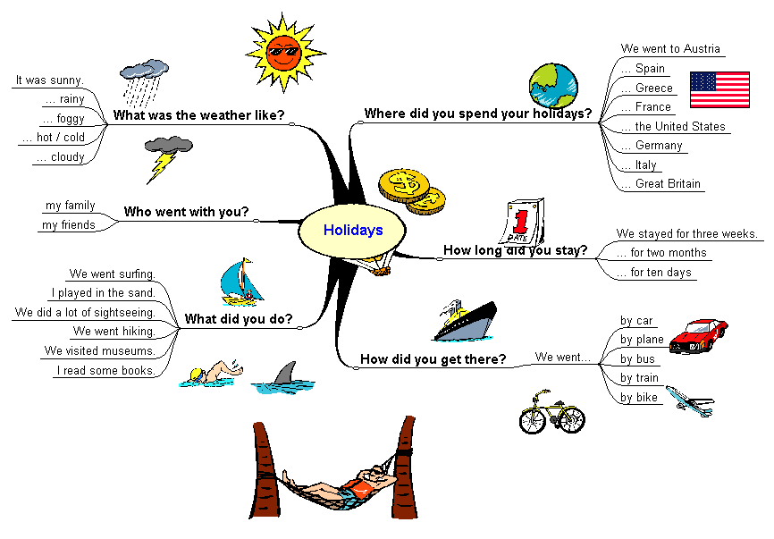

- Interview one of your friends about his/her holidays.

Name | Where did you spend your holiday? | How did you get there? | How long did you stay? | Who went with you? | What was the weather like? | What did you do?

- Write some sentences about your friend’s holidays (past tense).

e.g. My friend … spent his/her holidays in ….
He / she ….

Additional task:
Interview some more friends and take notes:

Name | Where did you spend your holiday? | How did you get there? | How long did you stay? | Who went with you? | What was the weather like? | What did you do?

