HOLIDAYS Explain the way
Bildmaterial: Quelle: The New You & Me 2, CD-Rom
I) Mark the route on the map:
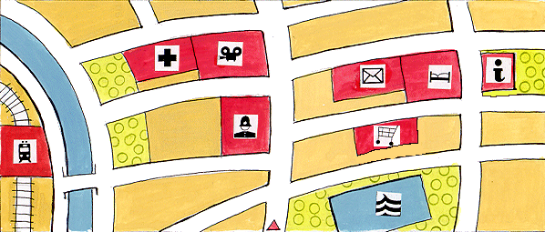
Make a green line where you have to go.
Go straight ahead and turn left after the police station. Turn right near the river. Take the first right. Walk past the hospital and the cinema. Then take the first right. Take the first left and go straight ahead. Turn right after the hotel. It is next to the post office and opposite the tourist office. Take the second right. On the left side there is a swimming pool. Go swimming!

II) Complete the dialogue:

Mr Lloyd: Excuse me, can you help me?
You: Yes, of course. What can I do for you?
Mr Lloyd: I would like to go shopping. Then I want to have a map from the tourist office. Then I want to go past the cinema to see which films are on. After that I would like to take the train back home. Could you please help me? Can you tell me the way?
You: ….

