HOLIDAYS Europe

Where is ...?
Draw lines.
Spain  Italy  Austria  Germany  Norway  Great Britain  France | 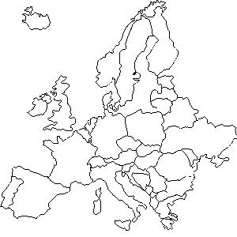 | Greece  Switzerland  Russia  Turkey  Portugal  Sweden  Poland

