FLORIDA

In FLORIDA there are a lot of sights which are worth seeing.
The most famous sights are:

Orlando: In Orlando there are the most famous parks of Disney World.

MAGIC KINGDOM: There are a lot of adventure-lands for children and grown-ups.
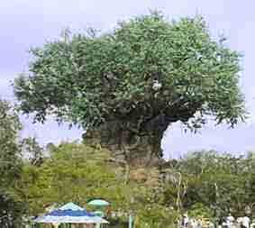
ANIMAL KINGDOM: It’s the newest attraction of the Disney group. The most interesting thing to see is the TREE OF LIFE.
There are hundreds of animal faces coming out of this tree. You can also visit LION KING and POCAHONTAS WORLD.

UNIVERSAL STUDIOS and SEA WORLD complete the offer of Disney Corporation.

Cape Canaveral: There you can see the famous KENNEDY SPACE CENTER. You can walk through the ROCKET PARK or watch the start of a space shuttle. Absolutely live!

Fort Lauderdale: In Ft.Lauderdale you can go on the “JUNGLE QUEEN”.
It’s a boat for tourists which makes a trip through the canals of Fort Lauderdale. You can see beautiful houses and palaces of very rich and famous people.(10– 20mill.$a house)

Key West: It’s the most southern part of Florida. In 1822 Key West defended the town from pirates. Nowadays you can visit ERNEST HEMINGWAY HOUSE and MUSEUM.

Everglades: It’s the widest (80km)and shallowest (15cm) river of the USA.
You can go ALLIGATOR ABBEY (from Miami to Naples) and there you can hire a boat. Along the river you will see a lot of gator farms presenting alligator-shows.
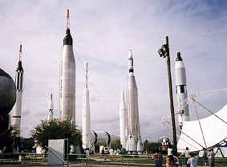
There you can admire fearless Indians fighting with big alligators.

Rocket
Park

