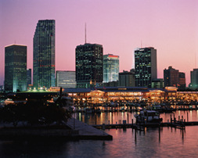
Florida

Florida is in the southeast of the USA.

Florida’s capital is

Florida earns most of its money from

The three largest towns in Florida are

A large number of people in Florida speak

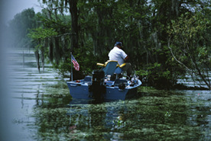
The most popular sport is

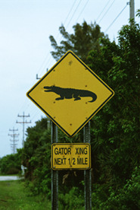
In Florida live about people.

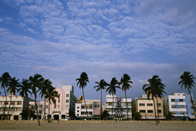
Floridians are allowed to kill alligator every year.

Sebring and Daytona Beach are famous for

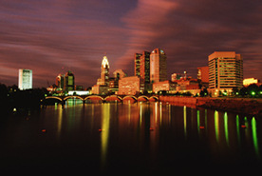
is closest to Miami.

